Obama Presidential Center Impacts
Chicago – Today, the Obama Foundation released an Economic Impact Assessment that estimates the potential economic impact that the Obama Presidential Center (OPC) will have on the South Side of Chicago, Cook County and the State of Illinois. The economic impact includes both potential jobs created as well as the estimated increase in tax revenue attributed to construction and ongoing operations of the OPC.
In Cook County, the assessment predicts that the construction of the OPC will support 4,945 direct, indirect and induced jobs created during the construction phase and 2,536 direct, indirect and induced jobs after the Center is open. Additionally, the analysis estimates the total number of annual visitors on a long-term basis is expected to range from 625,000 to 760,000.
Other key findings for Cook County include: an economic impact of $3.1 billion during the construction period and first ten years of operations for Chicago, with $675 million resulting from the construction phase and an annual impact of $246 million after the Center is open. In addition, the construction phase is anticipated to result in $16.5 million in indirect and induced state and local tax revenue. Post-construction, the analysis estimates the OPC will generate $5.9 million in annual indirect and induced state and local tax revenue.
For the South Side of Chicago, the OPC would result in an estimated economic impact:
Construction:
$339 million in economic impact
1,407 direct, indirect and induced jobs
Annual operation:
$177 million in economic impact
2,175 direct, indirect and induced jobs

For the State of Illinois:
Construction:
$883 million in economic impact
6,493 direct, indirect and induced jobs
Annual operation:
$266 million in economic impact
2,774 direct, indirect and induced jobs

Arizona Tourism Impacts
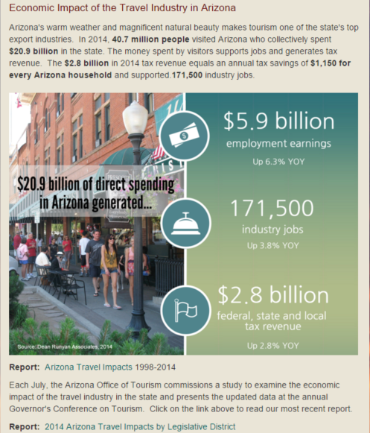

Storms & Natural Disaster Impacts
